🔷 1. Introduction to Transfer Learning
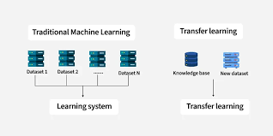
📌 What is Transfer Learning?
Transfer Learning is a deep learning technique where a model trained on one task is reused (fully or partially) for another related task.
👉 Instead of training a model from scratch, we transfer knowledge from a pre-trained model.

🧠 Simple Intuition
Think of it like this:
- You already know how to drive a car
- Now you learn to drive a truck
➡️ You don’t start from zero — you reuse prior knowledge

📊 Example
- A model trained on millions of images (ImageNet dataset)
- You use it to classify:
  - Cats vs Dogs
  - Medical images (X-rays)
  - Traffic signs

⚙️ How It Works
A deep learning model has layers:
- Early layers → detect edges, shapes
- Middle layers → detect patterns
- Final layers → task-specific classification
👉 In transfer learning:
- Keep early layers (feature extractors)
- Replace final layers (task-specific)

🔁 Types of Transfer Learning
- Feature Extraction
  - Freeze pre-trained layers
  - Train only final layers
- Fine-Tuning
  - Unfreeze some layers
  - Train with a low learning rate

🔷 2. Advantages of Transfer Learning in Deep Learning
✅ 1. Requires Less Data
- Training deep models from scratch needs huge datasets
- Transfer learning works well with small datasets
👉 Example:
- Medical imaging (few labeled samples)

✅ 2. Faster Training
- No need to train entire network
- Pre-trained weights already learned
👉 Saves:
- Time
- Computational cost

✅ 3. Better Performance
- Pre-trained models are trained on massive datasets like ImageNet
- They capture general features effectively

✅ 4. Avoids Overfitting
- Especially useful when dataset is small
- Model generalizes better

✅ 5. Less Computational Power
- Can run on:
  - CPU
  - Low-end GPU

✅ 6. Industry Relevance
Transfer learning is widely used in:
- Healthcare (X-ray classification)
- Autonomous driving
- NLP (BERT, GPT)
- Recommendation systems

🔷 3. Overview of Pre-trained Models
Now let’s go deeper into the most important models:
🔹 VGG
- Full form: Visual Geometry Group
- Named after the research group at the University of Oxford
- Examples:
  - VGG16 → 16 layers
  - VGG19 → 19 layers
👉 Known for: simple and deep CNN architecture

🔹 ResNet
- Full form: Residual Network
👉 Key idea:
- Uses skip connections (residual connections)
- Solves vanishing gradient problem
Examples:
- ResNet50 → 50 layers
- ResNet101 → 101 layers

🔹 Inception
- Originally called GoogLeNet
- Full form (GoogLeNet):
  - Named after Yann LeCun's “LeNet” + developed by Google
👉 Key idea:
- Uses parallel convolution filters (1x1, 3x3, 5x5) in one block
- Efficient computation

🟣 VGG16
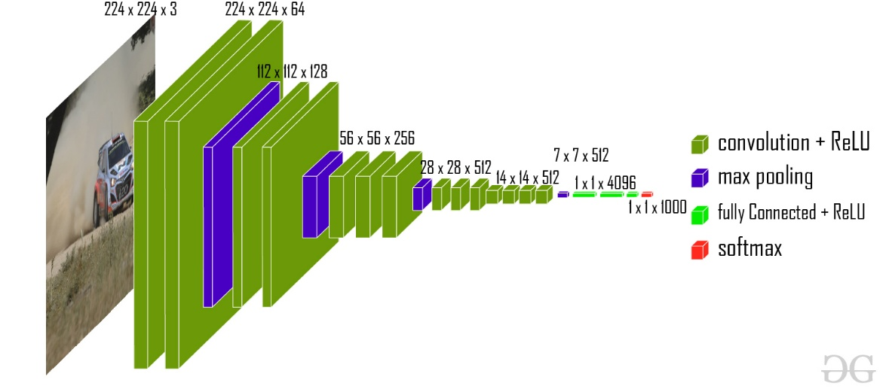
📌 Developed by:
- University of Oxford (Visual Geometry Group)

⚙️ Architecture
- 16 layers (13 conv + 3 dense)
- Uses only 3×3 convolution filters
- Very simple and uniform design

🔍 Key Features
- Deep but simple architecture
- Uses:
  - ReLU activation
  - Max pooling

✅ Advantages
- Easy to understand
- Good baseline model

❌ Disadvantages
- Very large (≈138 million parameters)
- Slow and memory-heavy

📊 Use Cases
- Image classification
- Feature extraction

🔵 ResNet
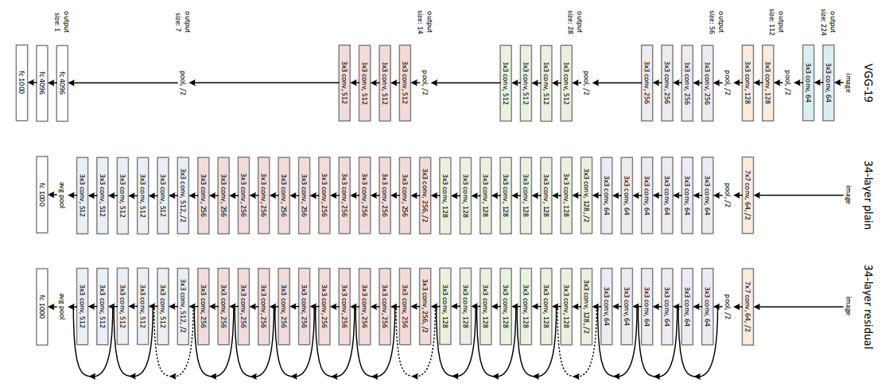
📌 Developed by:
- Microsoft Research

⚙️ Core Idea: Residual Learning
Uses skip connections (shortcut connections):
👉 Instead of learning:
Output = F(x)
It learns:
Output = F(x) + x

🧠 Why is this important?
Solves vanishing gradient problem in deep networks

🔍 Key Features
- Can go very deep (50, 101, 152 layers)
- Uses residual blocks

✅ Advantages
- Very deep networks possible
- High accuracy
- Widely used in industry

📊 Example
Used in:
- Self-driving cars
- Face recognition
- Medical imaging

🟢 Inception (GoogLeNet)
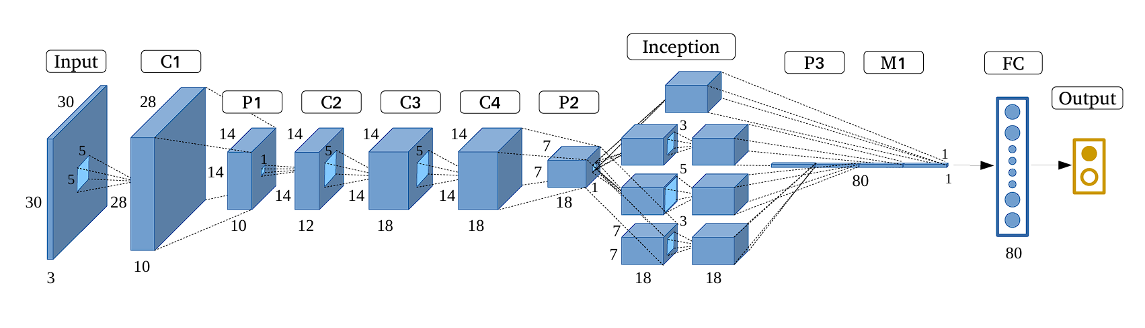
📌 Developed by:
- Google

⚙️ Core Idea: Inception Module
Instead of choosing one filter size:
👉 It uses multiple filters in parallel:
- 1×1
- 3×3
- 5×5

🧠 Why?
Capture features at multiple scales

🔍 Key Features
- Efficient computation
- Uses 1×1 convolutions to reduce dimensions

✅ Advantages
- Less computational cost
- High performance

📊 Use Cases
- Image classification
- Object detection

🔥 Comparison Summary
Model | Key Idea | Depth | Parameters | Strength
VGG16 | Simple deep CNN | 16 | Very High | Simplicity
ResNet | Skip connections | 50+ | Moderate | Accuracy
Inception | Multi-scale filters | ~22 | Efficient | Speed + Performance

🎯 When to Use What?
- Use VGG16 → when learning basics / simple tasks
- Use ResNet → when you need high accuracy
- Use Inception → when you want efficiency + performance

💡 Real-Life Example of Transfer Learning
🏥 Medical Imaging
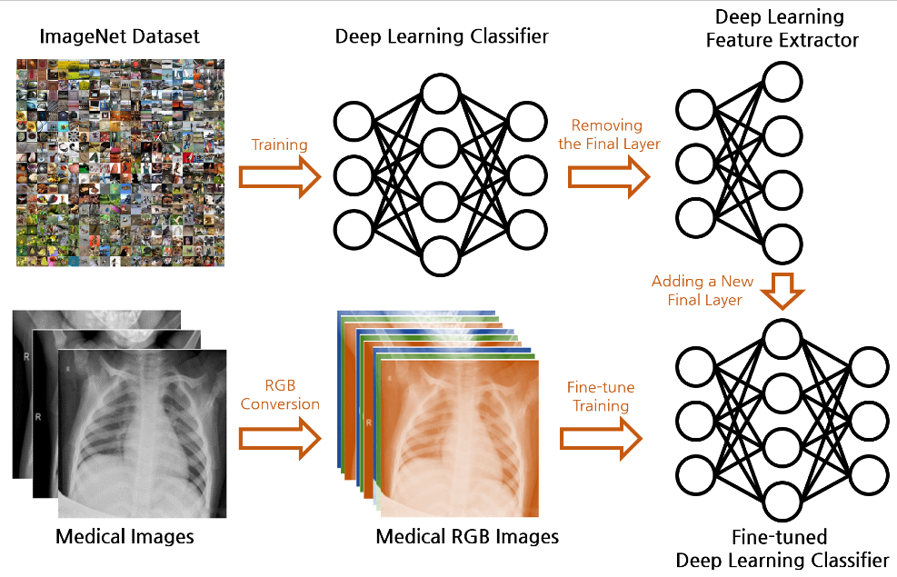
- Pre-trained ResNet on ImageNet
- Fine-tuned for:
  - Tumor detection
  - X-ray classification
👉 Even with small dataset → high accuracy

🚀 Final Takeaway
- Transfer Learning = Reuse knowledge
- Saves time, data, and compute
- Backbone of most modern deep learning applications

Types of Transfer Learning Models
A. Computer Vision (CNN-based models)
Used for: image classification, detection, regression
- VGG16 / VGG19
- ResNet (ResNet50, ResNet101)
- Inception (GoogLeNet)
- MobileNet
- EfficientNet
- DenseNet
👉 Use case:
- Classification → softmax output
- Regression → replace final layer with linear output

📌 B. NLP (Transformer-based models)
Used for: text classification, QA, chatbot, embeddings
Popular models available in Hugging Face Transformers:
- BERT (encoder model)
- GPT (decoder model)
- T5 (encoder-decoder)
- RoBERTa
- DistilBERT
- XLNet
👉 These are pre-trained Transformer models available via Hugging Face
👉 Hugging Face = library + model hub, not a model itself

📌 C. Time Series (Transformer-based transfer learning models)
These are VERY important for your question 👇
Available models in Hugging Face:
- TimeSeriesTransformer
- Informer
- Autoformer
👉 These are specifically designed for forecasting tasks
Key idea:
- Use attention to capture long-term dependencies
- Handle multivariate time series
👉 Example:
- Electricity demand prediction
- Stock forecasting

Advanced Time-Series Transformers
(Not all in Hugging Face but important)
- Temporal Fusion Transformer (TFT) → interpretable forecasting
- PatchTSMixer (MLP + transformer hybrid)
- Pathformer (multi-scale transformer)

📌 D. Audio / Speech Models
- Wav2Vec2
- HuBERT
Used for:
- Speech recognition
- Audio classification

📌 E. Multimodal Models
- CLIP (image + text)
- BLIP (vision-language)
- Flamingo (advanced multimodal)

📌 F. Generative Models (Image / Video)
- Stable Diffusion
- DALL·E
- ControlNet

